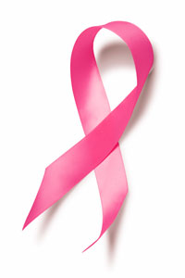Pink Ribbon Winter Classic
2019 Entry Form
Please fill out all the information on the registration form and return it along with the $100 registration fee to Baraboo Breast Savers Inc., PO Box 674, Baraboo WI 53913 oryou can register at North Shore Restaurant & Bar, E11614 Tranquility Lane, Baraboo WI 53913 by January 26th, 2019. There will be a $20 fee for any registrations received after January 26th, 2019. Sweatshirts can be preordered and all fees for sweatshirts must be submitted with the registration fee. Verification of your paid registration will be emailed to the Team Manager.
The first 10 teams to return their entry form and registration fee will be entered into a drawing for a certificate for a ¼ barrel of beer.

(Please Print)
Team Name: __________________________________________________________________
Team Manager Name: __________________________________________________________
Team Manager Email: _________________________ Phone Number: __________________
Team Member Names (First and Last Name):
_________________________________ ____________________________________
_________________________________ ____________________________________
_________________________________ ____________________________________
_________________________________ ____________________________________
Team Substitute Player Names:
_________________________________ ____________________________________
If you would like to pre-order sweatshirts, please include the size for each sweatshirt and submit the payment along with your registration fee.
Sizes and Prices: S-XL $30 each, XXL $35 each
Please indicate quantity of prepaid, preordered sweatshirts below:
Small ______ Medium ______ Large ______ XL ______ XXL ______

